Description: The user interacts with an Android application (UtilTracker) to add, maintain, or search utility data. The user must register/login from the main page in order to use the application. The user can then Add, Update or Delete their own utility data, and they can search their own data or others data (no personally identifiable information).

|  |  |  |  |  |  |  |  |  |
| --- | --- | --- | --- | --- | --- | --- | --- | --- |
| PROJECT NAME: UtilTracker Android App | | | | | | | | |
| Test Script Name: | | UtilTracker Main page | | | | | | |
| Scenario/Purpose: | | Validate all the functions of the UtilTracker Main page | | | | | | |
| Prerequisites: | | User must have internet access on the android device and the UtilTracker app must be installed | | | | | | |
| Name of Tester: | | Chris Brown | | | Date: | | 03/23/2019 | |
|  | |  | | | Time: | |  | |
| Steps | Description: | | Expected Results: | Pass | Fail | N/A | | Defect/Comments |
| 1 | Open the UtilTracker app | | The homepage displays. | Y |  |  | |  |
| 2 | Click the Login button | | The login page displays | Y |  |  | |  |

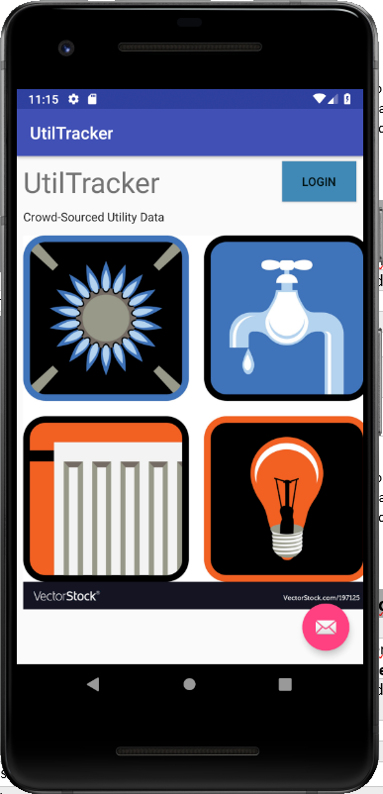

Description: The user interacts with an Android application (UtilTracker) to add, maintain, or search utility data. The user must register/login from the main page in order to use the application. The user can then Add, Update or Delete their own utility data, and they can search their own data or others data (no personally identifiable information).

|  |  |  |  |  |  |  |  |  |
| --- | --- | --- | --- | --- | --- | --- | --- | --- |
| PROJECT NAME: UtilTracker Android App | | | | | | | | |
| Test Script Name: | | UtilTracker Login page | | | | | | |
| Scenario/Purpose: | | Validate all the functions of the UtilTracker Login page  **\*\*NOTE: The register function of this page has not yet been implemented** | | | | | | |
| Prerequisites: | | User must have internet access on the android device and the UtilTracker app must be installed and the user has navigated to the Login page | | | | | | |
| Name of Tester: | | Chris Brown | | | Date: | | 03/28/2019 | |
|  | |  | | | Time: | |  | |
| Steps | Description: | | Expected Results: | Pass | Fail | N/A | | Defect/Comments |
| 1 | Enter an invalid userid (email address) / password and click the “Sign in or Register” button | | The login page displays “This password is incorrect”. | Y |  |  | |  |
| 2 | Enter an invalid email address as the userid and click the “Sign in or Register” button | | The login page displays “This email address is invalid” | Y |  |  | |  |
| 3 | Enter a valid userid with no password and click the “Sign in or Register” button | | The login page displays “This password is incorrect”. | Y |  |  | |  |
| 4 | Enter a valid userid with a password shorter than 8 characters | | The login page displays “This password is too short” | Y |  |  | |  |
| 5 | Enter a valid userid (email address) / password and click the “Sign in or Register” button | | The Menu page displays. | Y |  |  | |  |
| 6 | Click the Navigation left-arrow in the heading | | The Main page of the application is displayed | Y |  |  | |  |

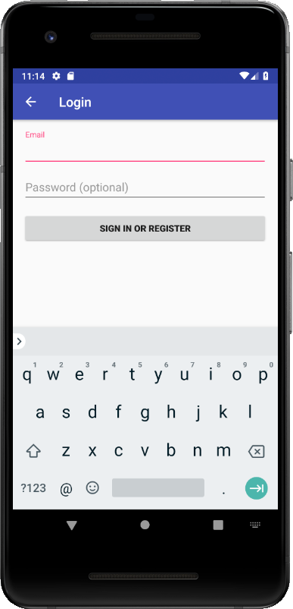 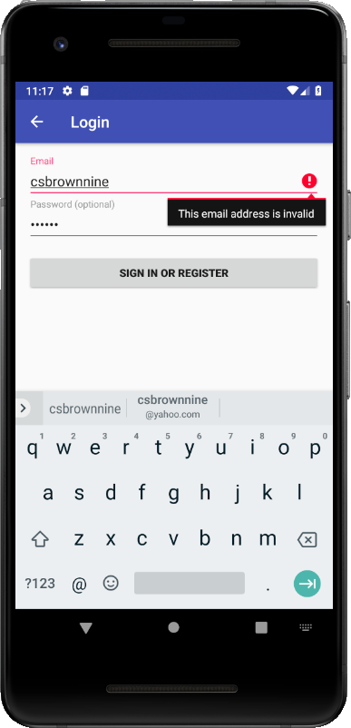

Description: The user interacts with an Android application (UtilTracker) to add, maintain, or search utility data. The user must register/login from the main page in order to use the application. The user can then Add, Update or Delete their own utility data, and they can search their own data or others data (no personally identifiable information).

|  |  |  |  |  |  |  |  |  |
| --- | --- | --- | --- | --- | --- | --- | --- | --- |
| PROJECT NAME: UtilTracker Android App | | | | | | | | |
| Test Script Name: | | UtilTracker Menu page | | | | | | |
| Scenario/Purpose: | | Validate all the functions of the UtilTracker Menu page  **\*\*NOTE: The Maintain Delete and Delete Utility functions have not yet been implemented** | | | | | | |
| Prerequisites: | | User must have internet access on the android device and the UtilTracker app must be installed and the user has navigated to the Menu page (by logging in). | | | | | | |
| Name of Tester: | | Chris Brown | | | Date: | | 03/31/2019 | |
|  | |  | | | Time: | |  | |
| Steps | Description: | | Expected Results: | Pass | Fail | N/A | | Defect/Comments |
| 1 | Click the “Enter Utility Data” button | | The “Add Utility” page displays | Y |  |  | |  |
| 2 | Click the “Search” button | | The Search Utility page displays | Y |  |  | |  |
| 3 | Click the “Logout” button | | The user is logged out and the Main page displays | Y |  |  | |  |
| 6 | Click the Navigation left-arrow in the heading | | You see the screen flash, but it remains on the Menu page | Y |  |  | | The Main page redirects to the Menu page when the user is logged in, so this is expected behavior. |

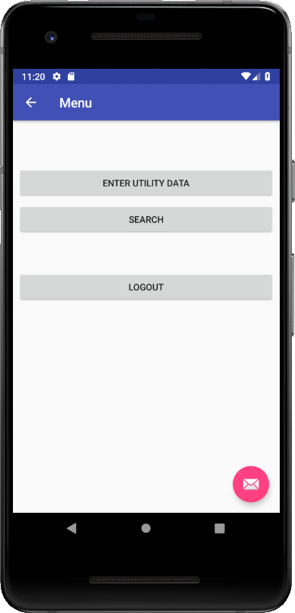

Description: The user interacts with an Android application (UtilTracker) to add, maintain, or search utility data. The user must register/login from the main page in order to use the application. The user can then Add, Update or Delete their own utility data, and they can search their own data or others data (no personally identifiable information).

|  |  |  |  |  |  |  |  |  |
| --- | --- | --- | --- | --- | --- | --- | --- | --- |
| PROJECT NAME: UtilTracker Android App | | | | | | | | |
| Test Script Name: | | UtilTracker Add Utility page | | | | | | |
| Scenario/Purpose: | | Validate all the functions of the Add Utility page | | | | | | |
| Prerequisites: | | User must have internet access on the android device and the UtilTracker app must be installed and the user has navigated to the Add Utility page, including logging in. | | | | | | |
| Name of Tester: | | Chris Brown | | | Date: | | 03/31/2019 | |
|  | |  | | | Time: | |  | |
| Steps | Description: | | Expected Results: | Pass | Fail | N/A | | Defect/Comments |
| 1 | Click the “Billing Month” drop-down and select a month | | The “Billing Month” drop down displays a properly ordered list of the months and allows you to pick one. | Y |  |  | |  |
| 2 | Enter a city name in the City field. | | You are able to type any sequence of alphabetic characters into the “City” field, but no non-alpha characters | Y |  |  | |  |
| 3 | Click the “State” drop-down and select a state | | The “State” drop down displays a properly ordered list of US states and allows you to pick one. | Y |  |  | | No validation of the city/state combination is performed |
| 6 | Enter a zipcode in the “Zip Code” field | | You are able to type any sequence of up to 5 numeric characters into the “Zip Code” field, but no non-numeric characters | Y |  |  | | The app does not validate the zipcode beyond limiting it to a maximum of 5 numeric characters. |
| 7 | Click the “Submit” button | | The record is added and the Menu page is displayed | Y |  |  | | Note: no notification that the record has been added is given. |
| 8 | Try to add a record without entering data into all the fields | | A “This field is required” n error message is displayed on all empty fields | Y |  |  | | Note: All spinner fields will automatically default to the top value in the drop-down and thus will not be empty. |
| 9 | Click the Navigation left-arrow in the heading | | The Menu page is displayed | Y |  |  | |  |

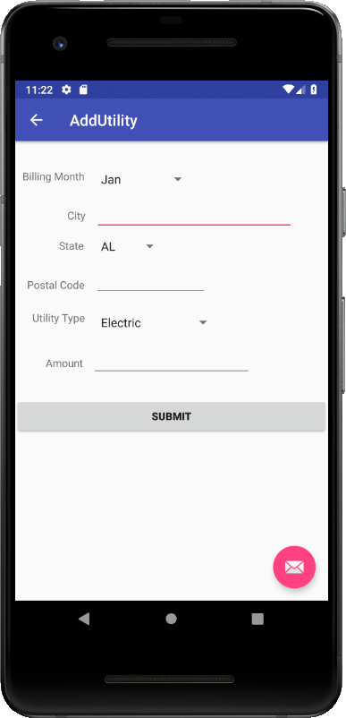 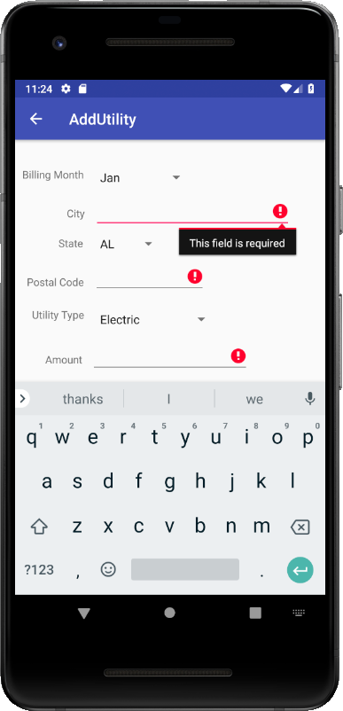

Description: The user interacts with an Android application (UtilTracker) to add, maintain, or search utility data. The user must register/login from the main page in order to use the application. The user can then Add, Update or Delete their own utility data, and they can search their own data or others data (no personally identifiable information).

|  |  |  |  |  |  |  |  |  |
| --- | --- | --- | --- | --- | --- | --- | --- | --- |
| PROJECT NAME: UtilTracker Android App | | | | | | | | |
| Test Script Name: | | UtilTracker Search Utility page | | | | | | |
| Scenario/Purpose: | | Validate all the functions of the Search Utility page | | | | | | |
| Prerequisites: | | User must have internet access on the android device and the UtilTracker app must be installed and the user has navigated to the Search Utility page, including logging in. | | | | | | |
| Name of Tester: | | Chris Brown | | | Date: | | 04/08/2019 | |
|  | |  | | | Time: | |  | |
| Steps | Description: | | Expected Results: | Pass | Fail | N/A | | Defect/Comments |
| 1 | Click the drop-down and choose an address (city) | | The drop down contains the list of all of the cities for which the user has entered utility data | Y |  |  | |  |
| 2 | Click the “Search” button | | A list of the months and average utility bill for that month displays for all of the utility data the user has entered. |  | Y |  | | This functionality has not been fully implemented, so nothing displays. |
| 3 | Click the Navigation left-arrow in the heading | | The Menu page is displayed | Y |  |  | |  |
|  |  | |  |  |  |  | |  |

